**Customer application**

**Dt:26 feb 2024**

**Lecture 62 postgres database configuration and docker-compose file:**

docker exec -it postgres bash

ls

psql-U lirus

\l to see the databases

\q exits out of psql

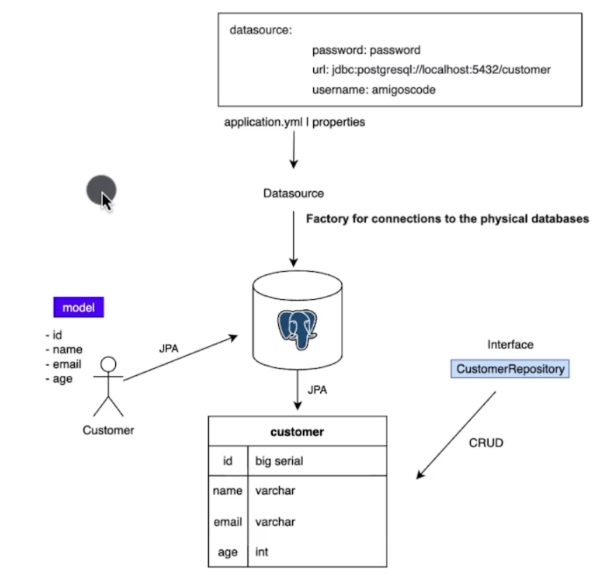

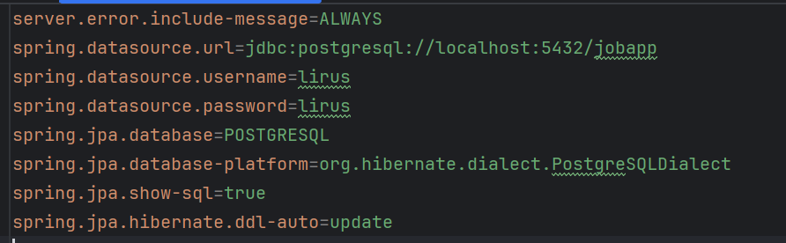

Creating customer repository

**Note:** Use qualifier while injecting dependency of multiple implementations for a given dependency

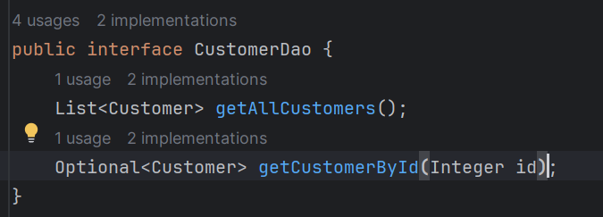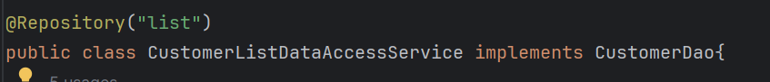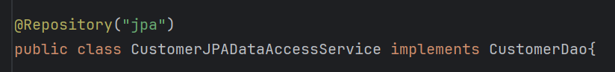

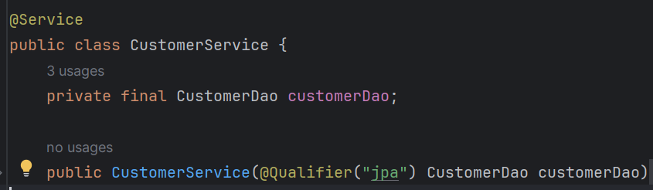

**Architecture diagram**

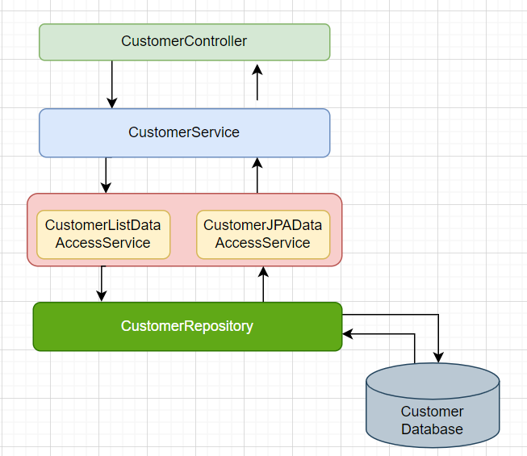

**Testing JUnit and Mockito**

* Test containers user docker images to test the application
* For testing we will use separate database container using this Test containers dependency
* Flyway we need to pass the arguments
* 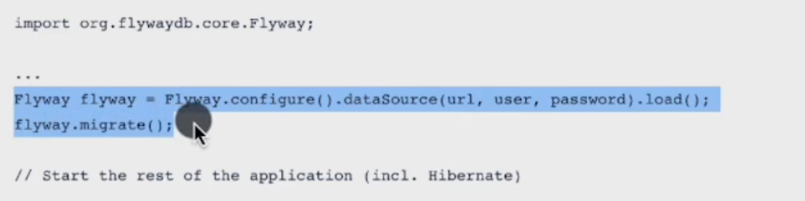

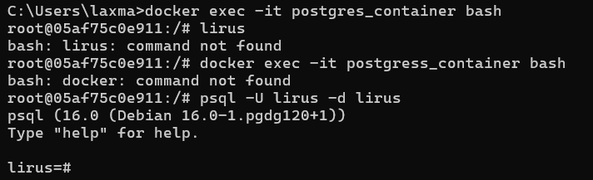

-d for database

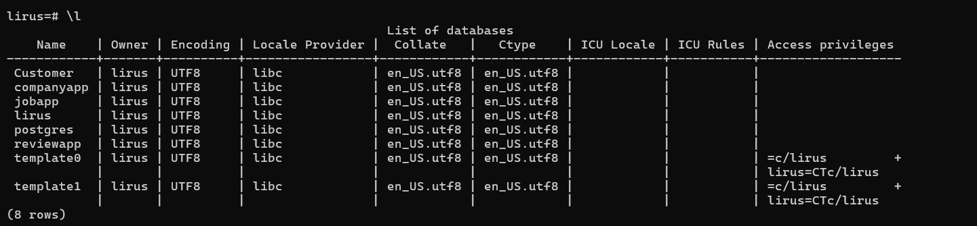

\l for list the database

\c database name to connect to the database

\dt to display the tables

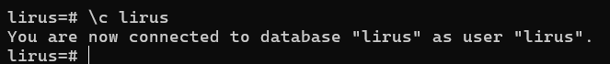

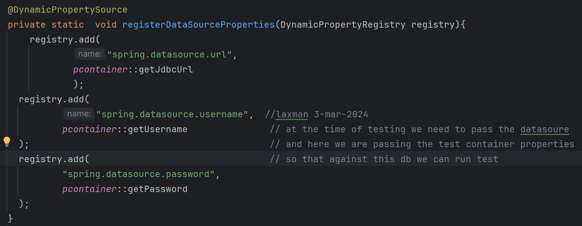

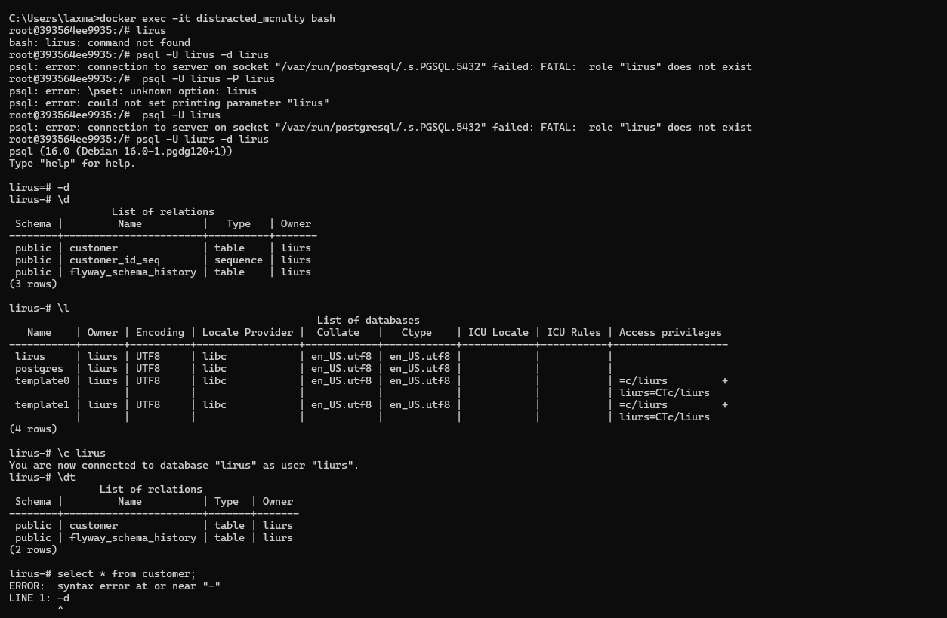

**Order of writing testing application using junit**

1. **flyway migration**
2. **Database configuration using testcontainers**
3. **Configuring datasource**
4. 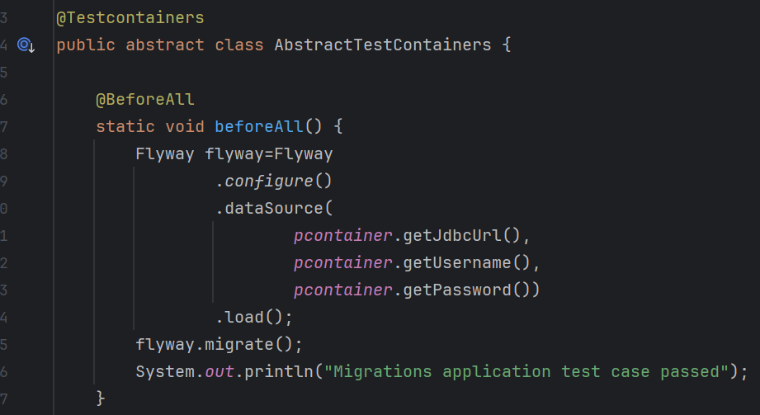
5. 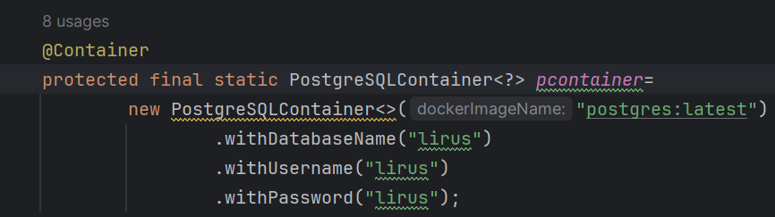
6. 